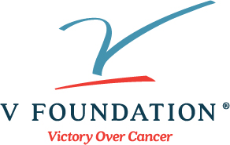

Nomination Form

2022 V Scholar (Adult Cancer) Research Grant
Nomination form is due by April 28, 2022
Email completed form and Letter of Recommendation to nominations@v.org
You may submit up to two nominees (on separate forms) from your research institution for consideration, if at least one of the two nominees identifies as someone from an underrepresented in science minority ethnic group (for the purposes of this nomination, see table below).

Nominated APPLICANT Contact Information: | Complete below ↓
First and last name (including degrees):

Name of Cancer Institute:

Professional Title:

E-mail address:
Phone number:
In order to help us determine if your nominee is eligible for special funding, please ask them to indicate the ethnicity(s) with which they self-identify: | ☐ Black or African American  ☐ Hispanic or Latino (non-European)  ☐ American Indian or Alaska Native  ☐ Native Hawaiian  ☐ Pacific Islander  ☐ I do NOT identify with any of these
Project Title and Key words (Include important key words related to the specific type of scientific expertise needed to select reviewers for your application): (Please enter into boxes below)
Project Title:
Key words (such as breast cancer, immunology, imaging techniques, epigenetics, microbiome, etc.):

Legal name of the research institution or medical system to which the grant will be made - as the name should appear in the grant contract: (Please enter into box below)

Grants Office Contact Information: | Complete below ↓
Grants officer name:

E-mail address:
I am the Cancer Center Director, or comparable Administrative Official responsible for the internal nominee selection process. By my signature, I am certifying that this is the individual who I am nominating and this nominee meets all applicant eligibility criteria:
Name and Title of Administrative Official: (Please enter into box below)

Signature of Administrative Official: (Please enter signature into box below)

