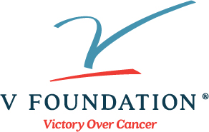

Nomination Form

2022 V Clinical Scholar Grant Program
Nomination form is due by March 15, 2022
Email completed form and Letter of Recommendation to nominations@v.org
Nominated APPLICANT Contact Information: | Complete below ↓
First and last name (including degrees):

Name of Cancer Institute:

Professional Title:

E-mail address:
Phone number:

Project Title and Key words (Include important key words related to the specific type of scientific expertise needed to select reviewers for your application): (Please enter into boxes below)
Project Title:

Key words (such as breast cancer, immunology, imaging techniques, epigenetics, microbiome, etc.):

Legal name of the research institution or medical system to which the grant will be made - as the name should appear in the grant contract: (Please enter into box below)

Grants Office Contact Information: | Complete below ↓
Grants officer name:
E-mail address:
Phone number:

I am the Cancer Center Director, or comparable official responsible for the internal nominee selection process. By my signature, I am certifying that this is the individual who I am nominating and this nominee meets all applicant eligibility criteria:

Name of Cancer Center Director or comparable official: (Please enter into box below)

Signature of Cancer Center Director or comparable official: (Please enter signature into box below)

Name of Nominee’s Department Chair: (Please enter into box below)

Signature of Nominee’s Department Chair: (Please enter signature into box below)

