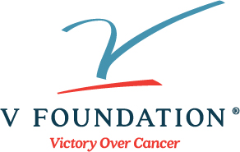

Nomination Form

2021 V Scholar (Adult Cancer) Research Grant
Nomination form is due by April 8, 2021
Email completed form to nominations@v.org
You may submit up to two nominees (separate form for each) from your research institution for consideration, if at least one of the two nominees identifies as someone from an underrepresented in science minority ethnic group (for the purposes of this nomination, see table below).

Nominated APPLICANT Contact Information: | Complete below ↓
First and last name (including degrees):

Name of Cancer Institute:

Professional Title:

E-mail address:
Phone number:
In order to help us determine if your nominee is eligible for special funding, please ask them to indicate the ethnicity(s) with which they self-identify: | ☐ African American  ☐ Hispanic American (non-European)  ☐ Native American  ☐ Alaskan Native  ☐ I do NOT identify with any of these
Project title: (Please enter into box below)

Legal name of the research institution or medical system to which the grant will be made - as the name should appear in the grant contract: (Please enter into box below)

Grants Office Contact Information: | Complete below ↓
Grants officer name:

E-mail address:
Phone number:
I am the Cancer Center Director, or comparable Administrative Official responsible for the internal nominee selection process. By my signature, I am certifying that this is the individual who I am nominating and this nominee meets all applicant eligibility criteria:
Name and Title of Administrative Official: (Please enter into box below)

Signature of Administrative Official: (Please enter signature into box below)

